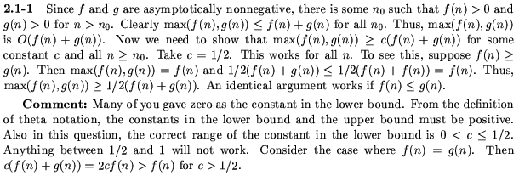

2.1-2)
(n+a)^{b} = θ(n^{b})
Find c₁, c₂, n₀ s.t. 0 ≤ c₁n^{b} ≤ (n + a)^{b} ≤ c₂n^{b} for all n ≥ n0
n + a ≤ n + |a| < 2n when |a| ≤ n
n + a > n - |a| ≥ (1/2)n when |a| ≤ (1/2)n

Thus 0 ≤ (n/2) ≤ n + a ≤ 2n when n ≥ 2|a|
Since b > 0
0 ≤ (n/2)^{b} ≤ (n + a)^{b} ≤ (2n)^{b}
0 ≤ (1/2)^{b}n^{b} ≤ (n + a)^{b} ≤ 2^{b} n^{b}
⇒ c₁ = (1/2)^{b}, c₂ = 2^{b}, n₀ = 2|a|

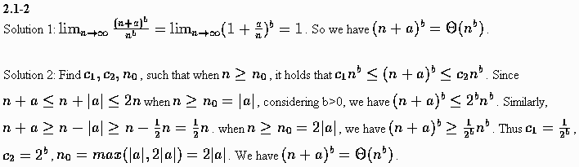

2.1-4)
2^{n+1} = Ο(2^{n}) ? Yes
For c=2, n₀ = 1
0 ≤ 2^{n+1} ≤ c2^{n} for all n ≥ n₀

2^{2n} = Ο(2^{n}) ? No
Assume 2^{2n} = Ο(2^{n}), so ∃ c,n₀ such that 0 ≤ 2^{2n} ≤ c2^{n} for all n ≥ n₀
Then 2^{2n} = 2^{n} *2^{n} ≤ c2^{n} for all n ≥ n₀
⇒ 2^{n} ≤ c , for all n ≥ n₀ , which is a contradiction
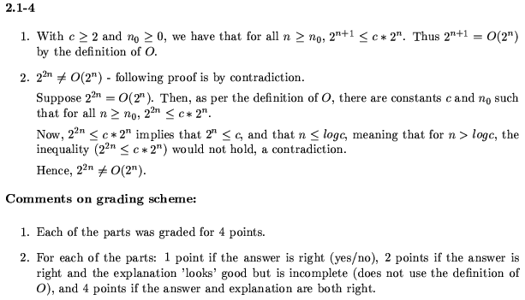
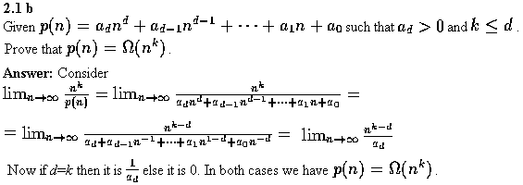


2-3
Ranking
1 ≅ n^{1/lgn} << lg(lg* n) ≅ lg* (lgn) << lg* n << 2 ^{lg* n} << ln ln n << √(lg) <<
ln n << lg² n << 2 ^{√(2lgn)} << (√2)^{lgn} (= 2 ^{1/2lgn} = √n ) << 2 ^{lgn} = n << lg(n!)
≅ nlgn << n ² = 4 ^{lgn} << n ³ << (lgn)! << n ^{lglgn} =(lgn)^{lgn} << (3/2)^{n} << 2 ^{n} <<
n.2 ^{n} << e ^{n} << n! << (n+1)! << 2 ^{2^n} << 2 ^{2^n+1}

Some Formulas:
lg(n!) ≅ nlgn – n
n ^{1/lgn} = 2
n ^{lg lgn} = lgn ^{lgn}
2 ^{lgn} = n
4 ^{lgn} = 2 ^{2lgn} = n ²

b) The basic idea to find a function f(n) is rather simple. We need this function to vibrate
between all its maximal values and minimal values. Our observation can be based on the
following facts: sin(x) and cos(x) vibrate between its maximal values and minimal values.

